COUNTY OF SAN DIEGO

JUVENILE JUSTICE
COORDINATING COUNCIL

March 5, 2024
1:00 – 2:30

Youth Transition Center (YTC)
Training Room

2801 Meadowlark Drive; San Diego, CA 92123

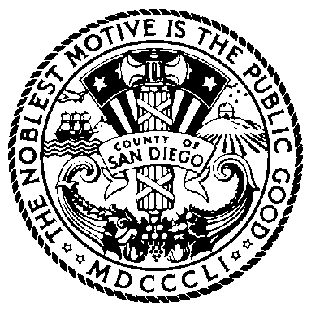
BOARD OF SUPERVISORS

NORA VARGAS
First District

JOEL ANDERSON
Second District

TERRA LAWSON-REMER
Third District

MONICA MONTGOMERY STEPPE
Fourth District

JIM DESMOND
Fifth District

Item | Subject
1 | Opportunity for Public Comment  Limit two minutes per speaker
2 | Welcome and Introductions
3 | Review Minutes (Action)
4 | Casa Nuestra Update
5 | Juvenile Arrest Data
6 | JJCPA Outcomes
7 | Updates  Probation  Public Defender  District Attorney  SDCOE  BHS  Other
8 | Legislative Update
9 | Kearny Mesa Master Plan - Phase 2
10 | Future Agenda Items

If you are planning to attend and need special accommodations, please call Brook Smith at (858) 581-5882 at least three days in advance of the meeting.

Pursuant to Government Code section 54957.5, materials distributed to the Juvenile Justice Coordinating Council in connection with this agenda less than 72 hours before the meeting will be made available to the public at https://www.thechildrensinitiative.org/jjccmeetings or https://www.sandiegocounty.gov/content/sdc/public_safety.html.

