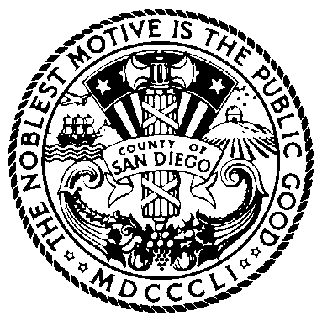

COUNTY OF SAN DIEGO
SB 823
Subcommittee of the Juvenile Justice Coordinating Council

Tuesday, April 11, 2023
11:00 a.m. – 12:00 p.m.

Meeting Location:
San Diego County Probation Administration Center
9444 Balboa Ave., Suite 500 – Executive Room
San Diego, CA 92123
Teams Link: https://tinyurl.com/3ce3yh4n

Agenda

Opportunity for Public Comment
Limit two minutes per speaker

- Update Juvenile Justice Realignment Plan – SB 823 (Action Item)

- Next Steps

If you are planning to attend and need special accommodations, you must call
Brook Smith at (858) 581-5882 at least three days in advance of the meeting.

Pursuant to Government Code section 54957.5, materials distributed to the committee in connection with this agenda less than 72 hours before the meeting will be made available to the public at https://www.sandiegocounty.gov/content/sdc/public_safety.html.

