gf

SB 823 Sub Committee

Minutes

April 21, 2021

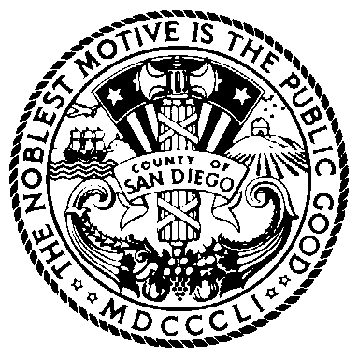

Present:

Scott Huizar, Probation
Matt Strickland, Probation
Brook Smith, Children’s Initiative
Lisa Weinreb, District Attorney
Joy Singleton, Community Rep
Sandy Keaton, SANDAG
Fran Cooper, HHSA
Mary Beth Wirkus, Public Defender
Dorothy Thrush, Public Safety Group
Lisa Sawin, Probation
Sandy Keaton, SANDAG
Marc Regier, Probation
Dana Maier, County Council
Alex Zermeño, Probation
D’Andre Brooks, Community Rep
Stephanie Heying, Children’s Initiative
Brook Smith, Children’s Initiative
Bennett McManus, Children’s Initiative
Shawnalyse Ochoa, District Attorney
Dr Carlos Nelson, HHSA, Behavioral Health
Jeff Collins, Public Safety Group
Bria Adams, Public Safety Group
Carlos Munoz, Parent Survivors
Elizabeth Munoz, Parent Survivors
Scott Laudner, Probation Officers Association

- Opportunity for Public Comment
- Brook Smith asked if there were any public comments and, after some time, stated that there were none.

- Welcome and Introductions
- Brook Smith called the meeting to order at 3:16 PM. He welcomed the SB 823 Sub Committee and called role for all SB 823 Sub Committee members.

- Announcements
- Scott Huizar announced that a PowerPoint presentation was going to be presented by Matt Strickland (Probation) and Stephanie Heying (Children’s Initiative) Scott Huizar then went on to state that the SB 823 committee would be meeting on a monthly basis and is in the processes of developing the required plan for SB 823.

- Data Update
- Matt Strickland started PowerPoint with an update regarding the ages of San Diego youth admitted to DJJ in 2020, the number of San Diego commitments to DJJ in 2020 (24), and the number of San Diego Youth paroled from DJJ in 2020 (18).

- Legislative Update SB-92
- Stephanie Heying went over the major provisions of SB 823 and SB-92 which include, DJJ closure date of June 30th, 2023 and the framework for youth in secure treatment facilities.

- Framework for Secure Youth Treatment Facility (SYTF)
- Matt Strickland introduces DJJ realignment action plan goals that include: education & employment, treatment, facility environment & staffing, program fidelity, and reentry.
- Matt Strickland described possible improvements to make setting more: homelike, trauma-informed, developmentally appropriate, and acceptable for longer commitments.
- Matt Strickland went over potential step down and furlough options that include: family reunification, job placement, education support, and obtaining a CA ID.

- Closing
  - Brook Smith thanks everyone for participating and informs committee that the next meeting will be held May 19th @ 3:15

Next Meeting:
Wednesday, May 19, 2021

Meeting minutes were submitted by Brook Smith. Please call him at (858) 581-5882 if you have corrections or suggested revisions. He may also be contacted for agenda items or general information. Thank you.

