COUNTY OF SAN DIEGO

JUVENILE JUSTICE
COORDINATING COUNCIL

Wednesday, August 23, 2023
1:00 – 2:30 p.m.

Probation Administration Center
9444 Balboa Ave., Suite 500
San Diego, CA 92123

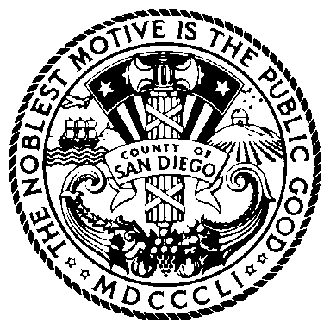
BOARD OF SUPERVISORS

NORA VARGAS
First District

JOEL ANDERSON
Second District

TERRA LAWSON-REMER
Third District

VACANT
Fourth District

JIM DESMOND
Fifth District

Agenda

Item | Subject
1 | Opportunity for Public Comment  Limit two minutes per speaker
2 | Welcome and Introductions
3 | Review Minutes (Action)
4 | DA/SANDAG – Juvenile Diversion Initiative (JDI)
5 | Youth Development Academy (YDA)  - Fuels/Fire Crew Program  - YDA Services
6 | Updates  Probation  Public Defender  District Attorney  SDCOE  BHS  Other
7 | Legislative Update
8 | Kearny Mesa Master Plan  - Phase 2
9 | Future Agenda Items

If you are planning to attend and need special accommodations, please call Brook Smith at (858) 581-5882 at least three days in advance of the meeting.

Pursuant to Government Code section 54957.5, materials distributed to the Juvenile Justice Coordinating Council in connection with this agenda less than 72 hours before the meeting will be made available to the public at https://www.thechildrensinitiative.org/jjccmeetings or https://www.sandiegocounty.gov/content/sdc/public_safety.html.

